**Linux Intro**

* echo $0 - shows the name of the shell we are using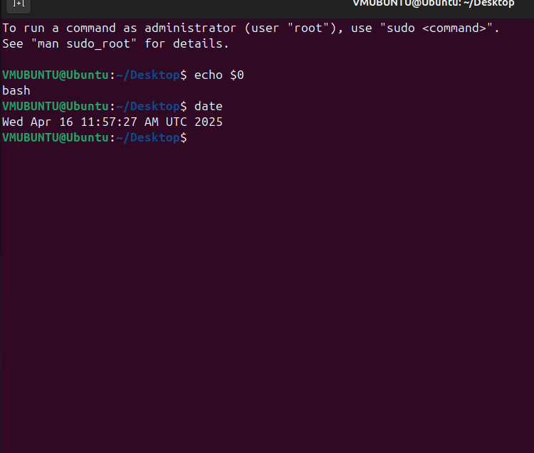
* date - shows the time and date

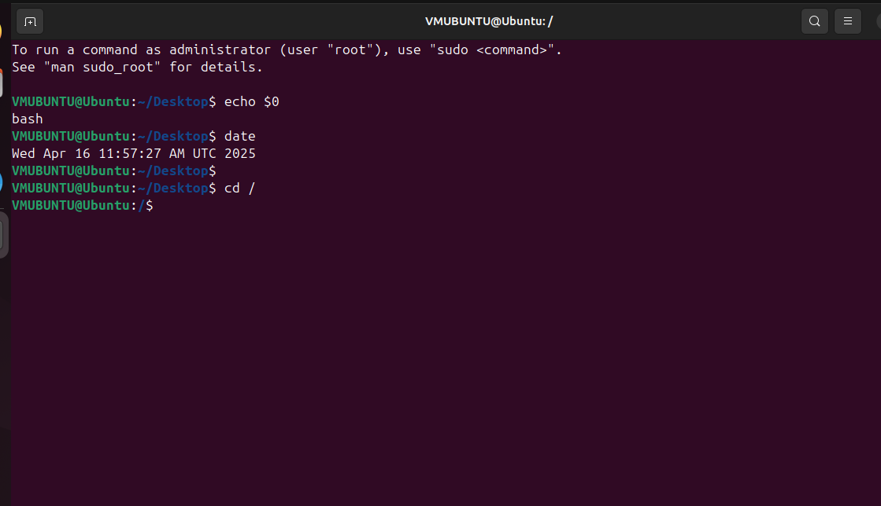

* “/” - is the root directory
* “cd” - is for change directory
* “cd /” - changes current directory to root directory

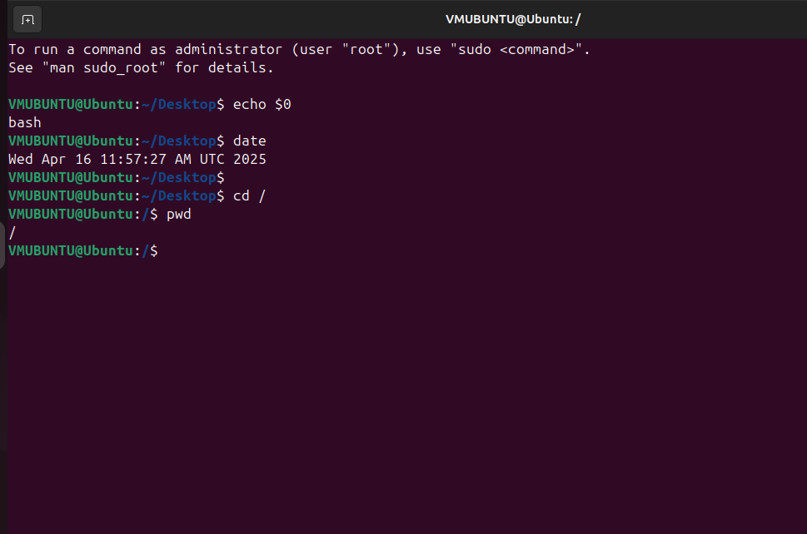

* “pwd” - present work directory

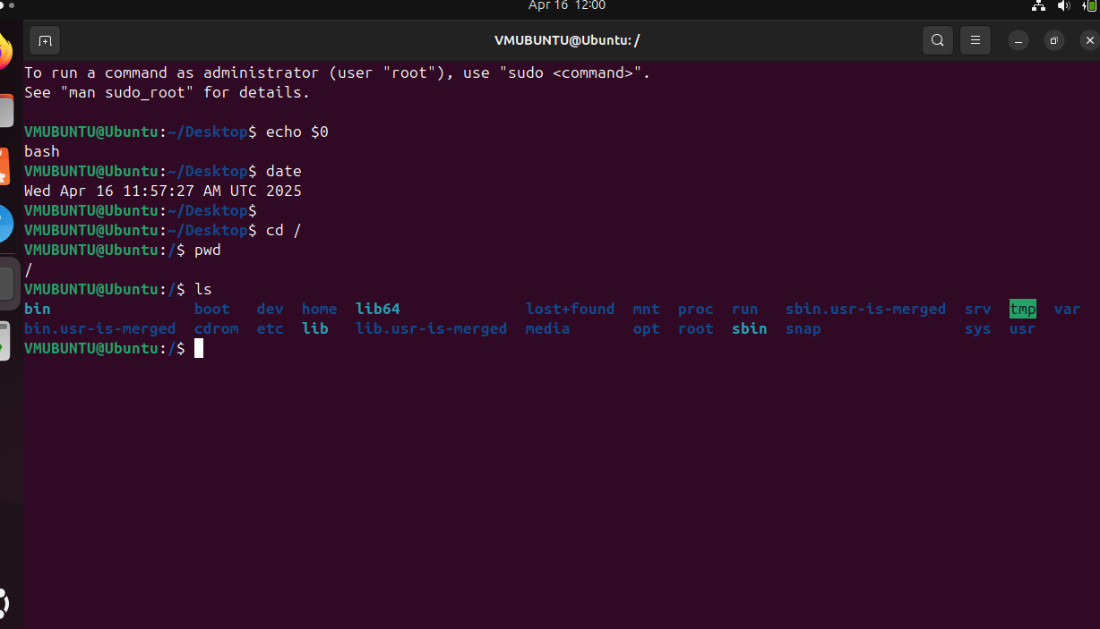

* “ls” - list of files in the current directory

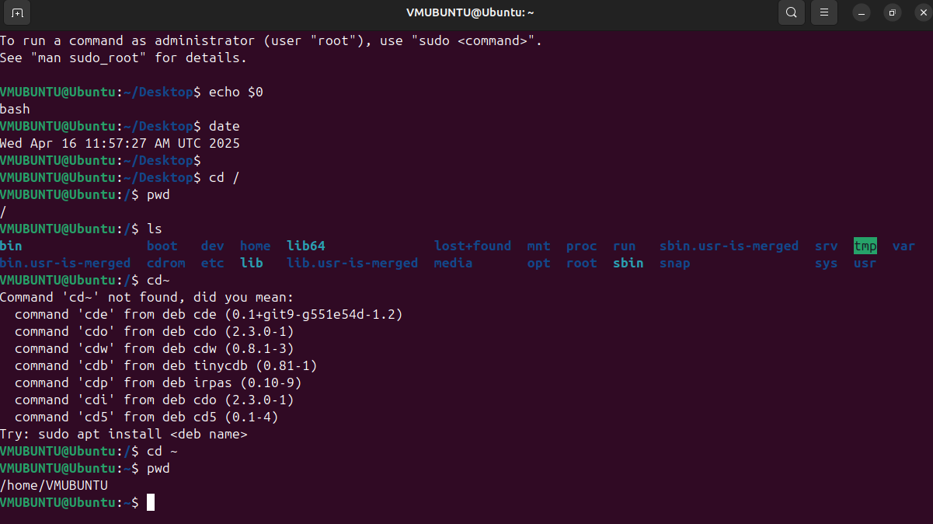

* “~” is for home directory
* “cd ~” takes us to the home directory
* now pwd shoes the name of the home directory

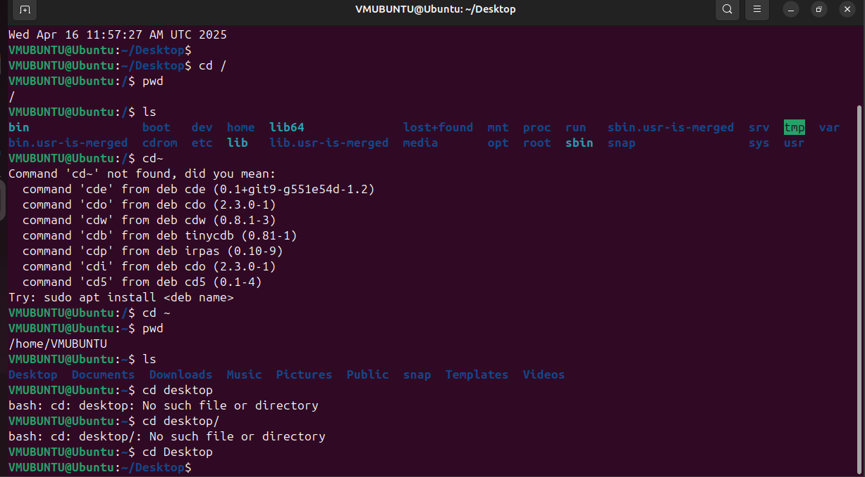

* “cd desktop” - changes the directory to desktop folder

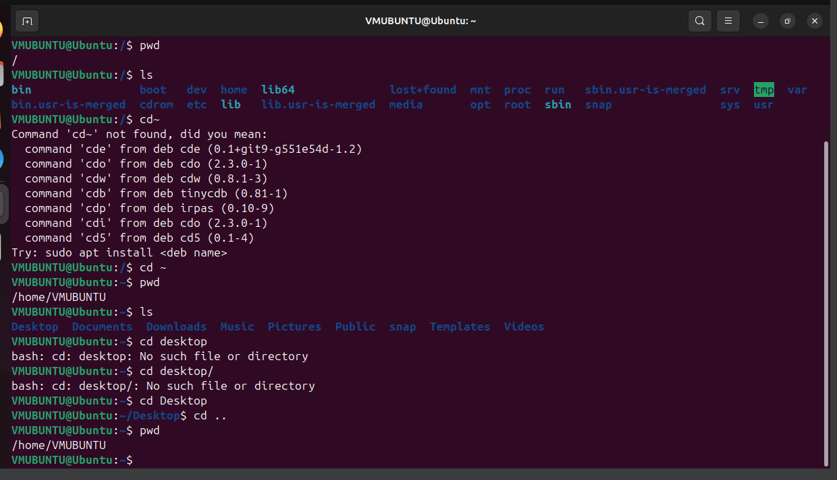

* cd .. - takes one step back

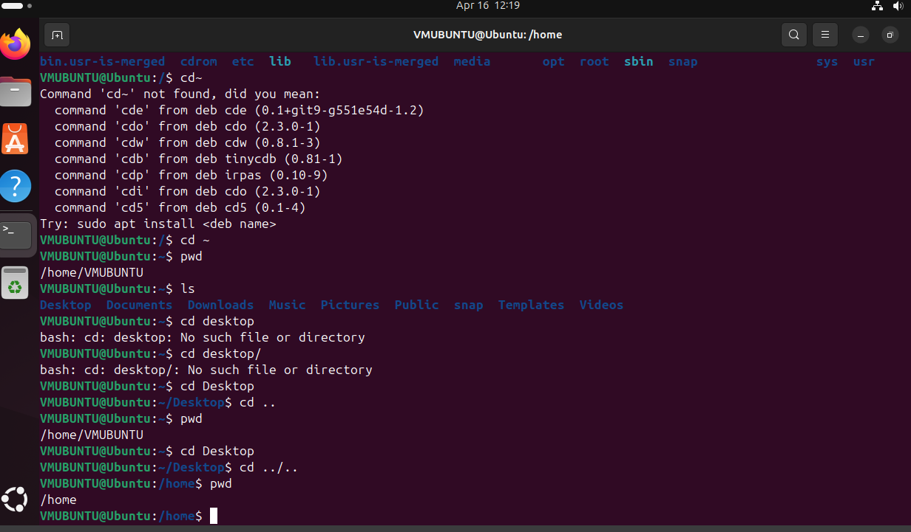

* cd../ .. - takes two steps back

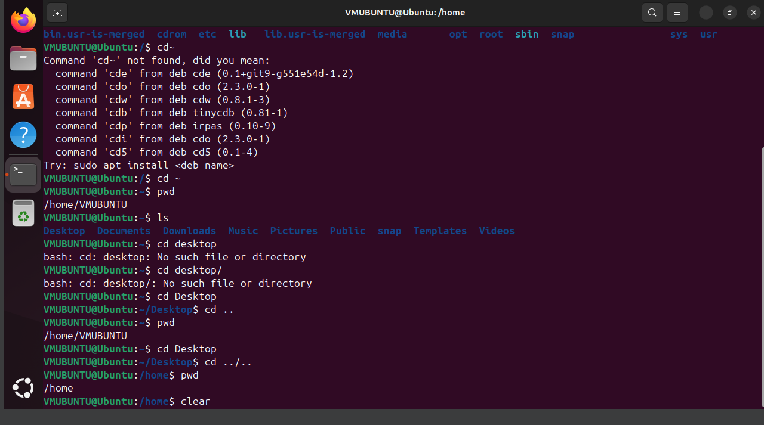

* clear - clears the commands from before

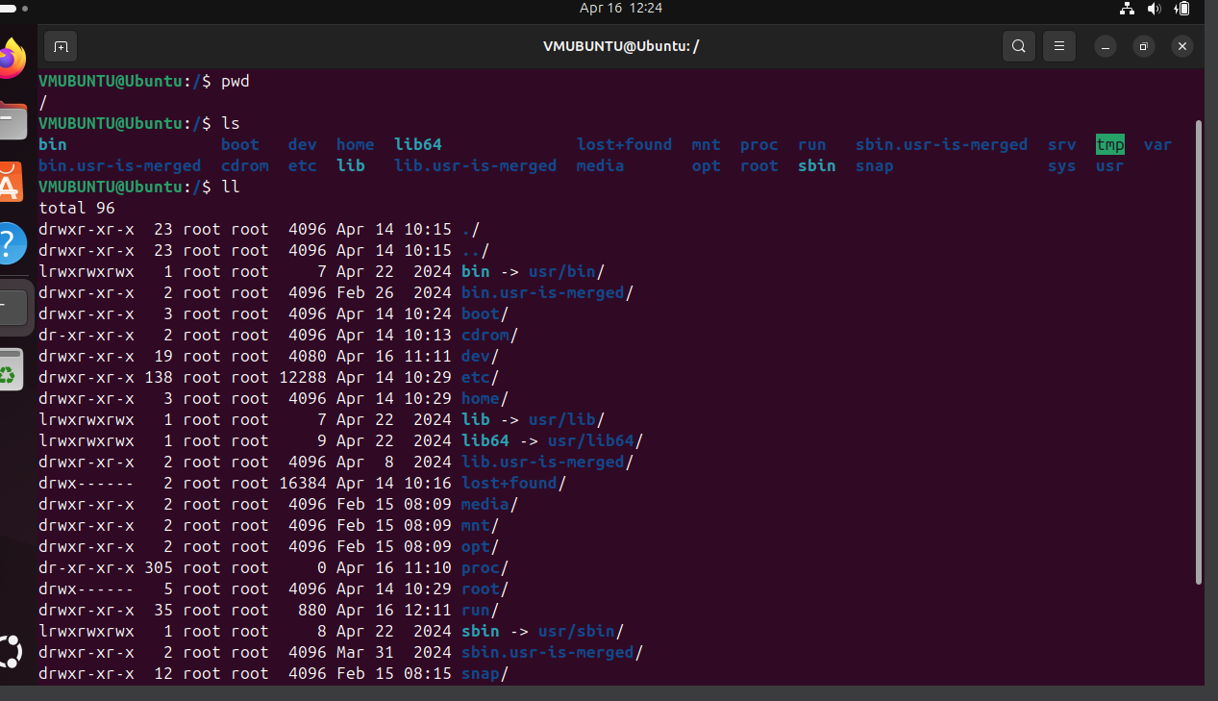

* ll - long list

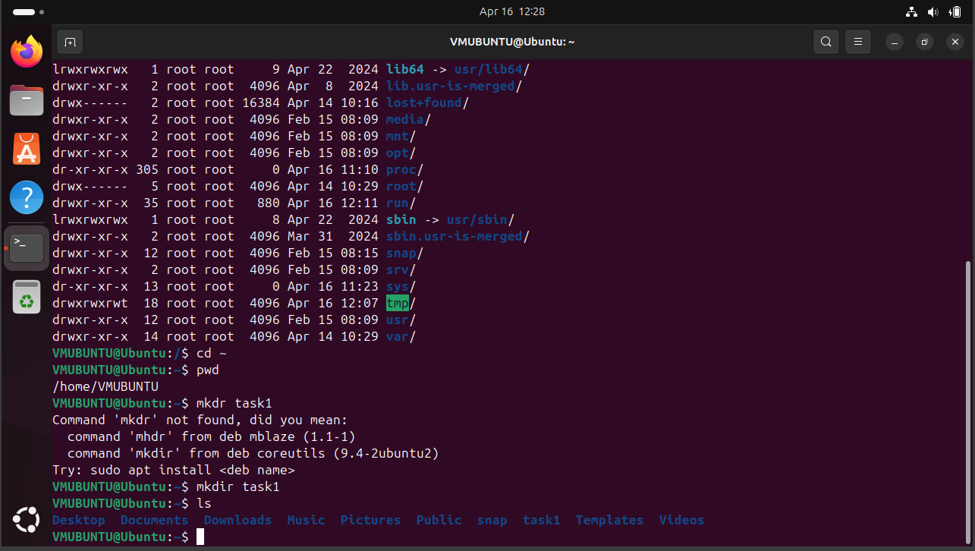

* mkdir - makes a new directory with whatever name you give

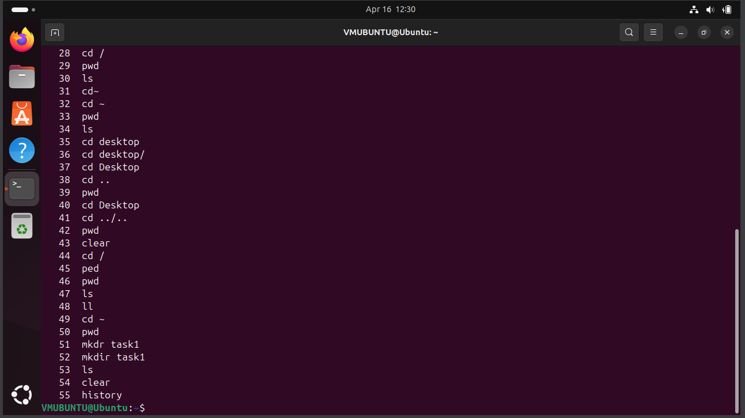

* history - shows how many commands have been executed

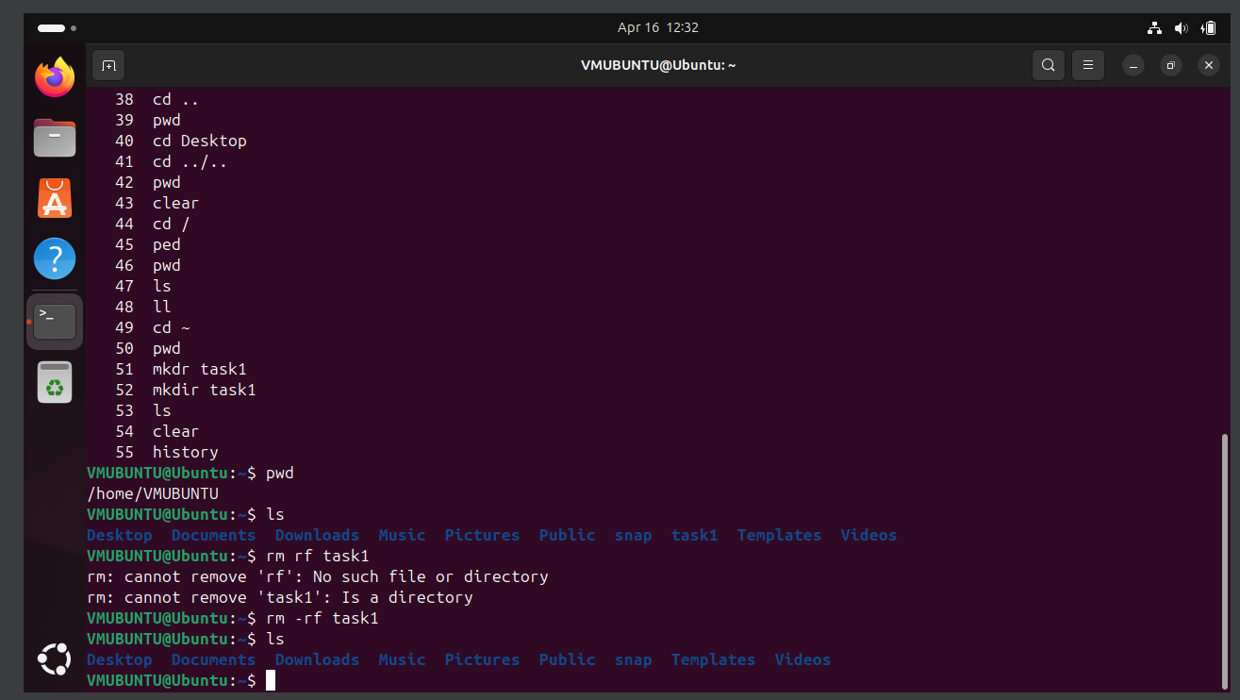

* rm -rf - deletes the specified directory

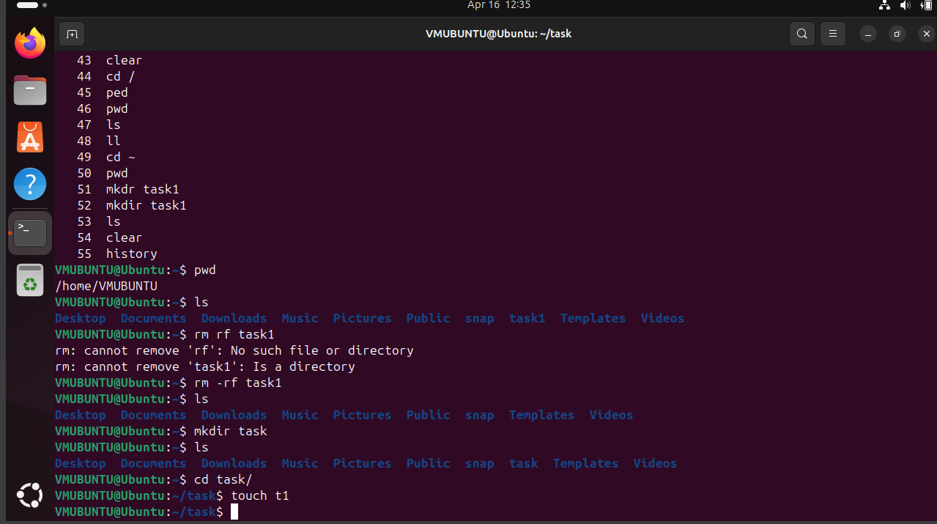

* touch - creating a file

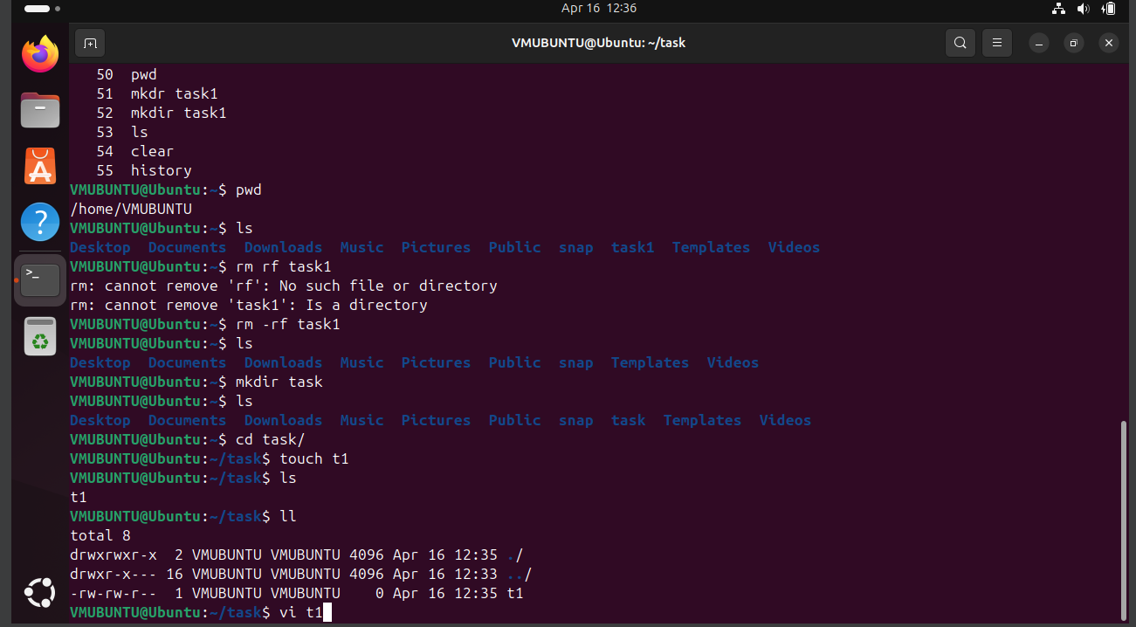

* vi file_name - for writing inside the file

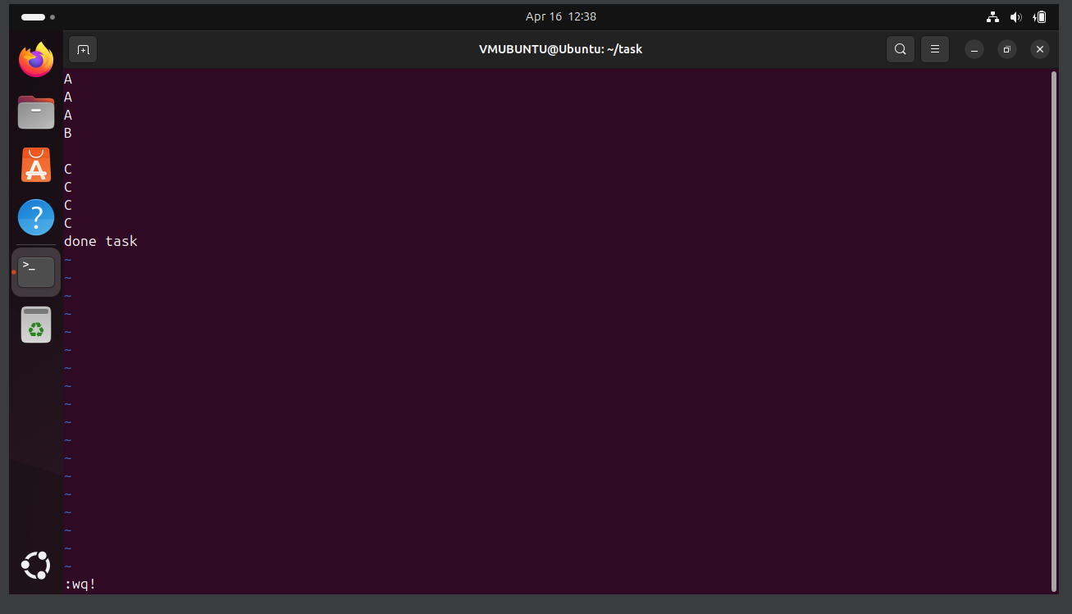

esc then :wq!- save and exit the file

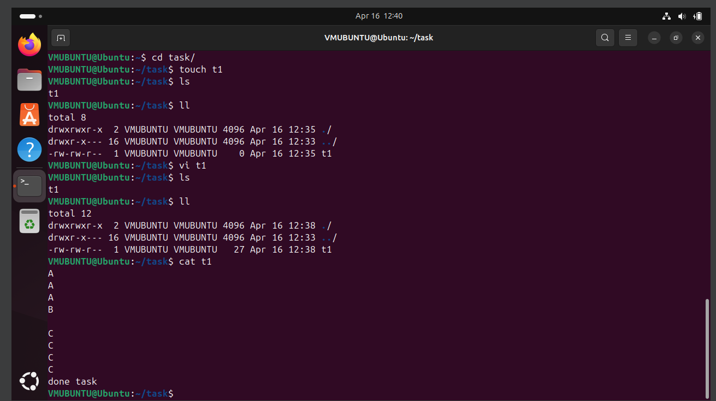

cat file_name- for reading the contents of the file

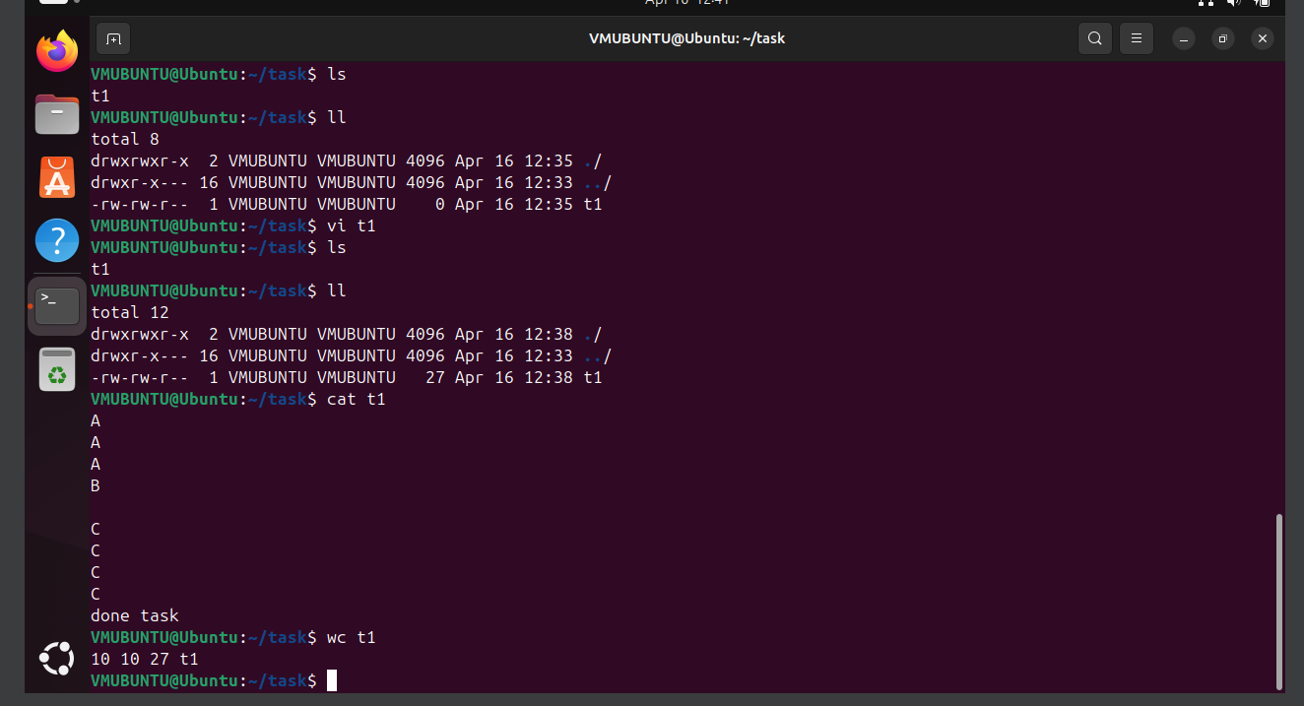

wc file_name - shows us the world count, rows